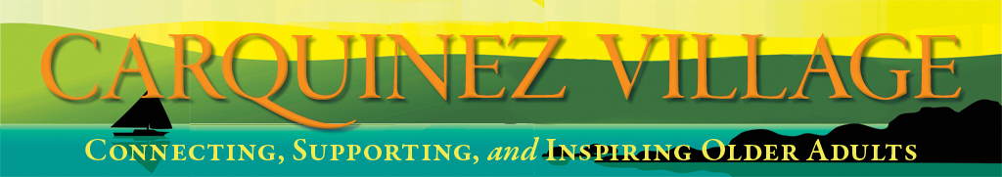

September 2020

Presidents Message  By Susan Neuhaus  The dog days of August, hopefully that is not going to offend too many, are behind us. I’m glad to see them go with the heat and then the wildfires on top of everything else.  It was a busy month for the Village, a revised Member Directory made its way to your home. This revision was inspired by one of your fellow members, Larry Clark, who commented on some inaccuracies in our inaugural version.  Judie Donaldson, founding board member, led the work with lots of help from Member Services and other committees and the eagle editing eye of Jeanne Ekdahl. I hope you will use it when you have a question on how something works.  Ever since the beginning of Covid we have been looking for new opportunities to partner with the community. One of those groups is Benicia Strong, a local group of non-profits and faith-based communities addressing food insecurity. Through #Food is Free Solano we have been able to get excess produce to members. As of the publication of this newsletter, The Food is Free Program is gearing up to change the contents of the food boxes to include more protein starting sometime is September while supplying food to fire victims. More information will follow soon. We are also participating in the Solano Senior Coalition 2-year plan on Active Aging.  Racial justice issues were a topic of discussion at our board meeting. Board Vice president, Diane Choquette has written an article about it later in the newsletter.  And we had an amazing number of new Zoom programs. You can now join us not for just speakers and discussion, but we now have a new cooking show and Do It Yourself program led by members.  So here we are in September, I’m hoping for cooler, clearer skies and that everyone stays safe. | 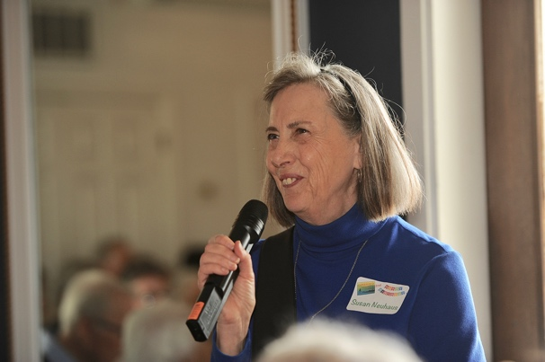  Inside this issue:  Carquinez Village  Values Statement 2  Neighborhood Groups 2  New Member,  Christa Shannon 2  Round Hole, episode 2 ….4  Mom 3  - Family 4  Notes from the editor 5  Want More  Involvement? 5

Neighborhood Groups |  | Carquinez Village Values Statement  In response to the racial justice issues raised by the Black Lives Matter movement, our village board of directors has discussed how we might voice our concerns and values. That discussion resulted in a three part plan: 1) to create a values statement that reflects our commitment to deepen our understanding of systemic racism and to seek ways in which all older adults can share equally in opportunities to lead fulfilling lives; 2) to offer related educational opportunities to our members and volunteers; and 3) to develop advocacy on issues related to older adults.  At our board meeting on August 4, we adopted the values statement below. This statement will be posted to our website and included in volunteer training materials, the Member Handbook, and our Employee Handbook.  "Carquinez Village envisions a world where all older adults share equally in the opportunity to age with dignity, purpose, and well-being and to live happy and fulfilling lives. We recognize that individual and societal change is required if this vision is to be achieved, and that this will entail the uprooting of institutional racism and its climate of social and racial inequity.  Carquinez Village recognizes that we are a part of the system in need of change. Our commitment is to strive to find ways to deepen our understanding of the role that we play, endeavor to erase inequities, and increase the diversity of our members."
In March, at the beginning of the Covid-19 shelter-in-place mandate, volunteer and data base guru, Sue Medrano worked many hours to create neighborhood maps of where all our members and volunteers live. Volunteers then used those neighborhood groupings to call and check on all of you, making sure that you were safe, knew how to get your groceries, medications and encouraging you to sign up for Solano Alert. Our Member Services Committee is now thinking about how those neighbor groupings might be used to build further connections and community. Clearly, they could be used in emergency situations to provide mutual aid and support to each other. What else? You might find you have common interests and enjoy getting to know each other.
Right now, that might be through Zoom get-togethers or small outdoor get-togethers. Those might evolve to potlucks or other social activities when it is safe to do so.

Our Vallejo members have created a model that is working well. Board member Linda Cook initially organized the get-togethers last year. Now they call each other and meet monthly for a Zoom discussion that member Marty Stockard facilitates.

So, expect to hear from Janice Magner or another one of the dynamic Member Service Committee about forming your neighborhood group.

Christa Shannon
By Diane Delaney

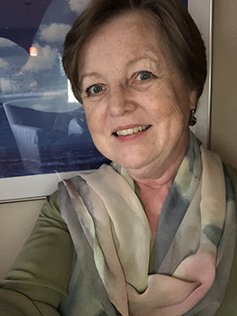
Please join me in welcoming new Village member, Christa Shannon. Christa grew up in Cologne, Germany before emigrating to the U.S. at age 28. She studied English and French Literature and received a prestigious Fulbright Scholarship to study Comparative Literature at Indiana University in Bloomington, Indiana, where she earned her master’s degree. Christa met her husband Tom there, another Fulbright Scholar, studying for his PHD in the Department of German.

Following her U.S. studies, Christa was required to return home to Germany for two years, before returning to the states and the Bay Area, where her husband has been a Professor in the Department of German at UC Berkeley for over 40 years.

Christa worked for 30 years for an International Exchange Program that allows foreign and domestic students the opportunity to spend a year immersing in a new language and culture. Christa and Tom have a daughter, Stephanie, who currently lives in San Francisco. Christa is now happily retired, and enjoys travel, socializing with friends, meeting new people, and participating in a philanthropic group at UC Berkeley.

MOM
by Molly Barr

I was talking to my sister on the phone the other day. I admitted that the fires in California have me freaked. My sister said, “well, you know, the California fire season put us through college.” A slight exaggeration, but only slight.

So today I remember my mother. Mother, teacher, mentor--and when fire season came to Northern California every summer, Mom took to the skies. She was the first female pilot to fly for the Forest Service. She was a contract, seasonal lead plane pilot for the California North Zone Air Unit. The lead plane is the plane that leads the air tankers into the heart of a fire to drop their load of fire retardant. I don’t know if lead planes are used in current day. I’m sure fire fighting is much more sophisticated. But I remember the long days in the hot summers when mom would be in the skies. We--my sister and I--grew up on a tiny airport on the eastern slope of the Sierra Nevada mountain range, on the edge of the desert, 80 miles north of Reno, Nevada. We ran around bare-footed and half wild while Dad operated the airport and mom flew lead plane.

Mom: Mary Barr 1925 - 2010
The Stories of Your Life  By Lois Requist  Reminiscing is part of aging. We have so many memories! Writing our stories, our memoirs, enables us to pass them along to family, friends, or even the public. It also helps us remember these happenings.  I’ll be teaching a memoir class on Zoom each Tuesday afternoon from 1 to 2:30 pm for six weeks beginning October 6th. We’ll be talking about how to get those stories written. We’ll practice in class. Who are the characters that will inhabit your stories? How about the places? The time in which they took place? We’ll share our stories and learn from each other.  If you’d like to be a part of the class, you can sign up at the Carquinez Village website, https://www.carquinezvillage.com/ or call 707-297-2472. If you have questions about the class, please call me, at 707-280-0588.  “I remember the long days in the hot summers when mom would be in the skies.”  Family  By Joe Athey  When mom’s mother joined the suffragettes, grandpa put up a sign: “Needed: cook and maid. Suffragettes need not apply.” Grandpa’s family was from Missouri. Grandma’s family stretched all the way back to New Amsterdam. I had a sweet all-American mom.  Dad’s side was different. His father came directly from England’s coal mines. He married a Newcastle widow with two young kids. And took them to the coal mines of Iowa where both kids died. Then my dad and aunt were born. Grandma divorced grandpa and took all the money (but not the kids). Well, that’s what I remember. And I love them still.  My family is alive to me through memories. I hope yours is as well. | 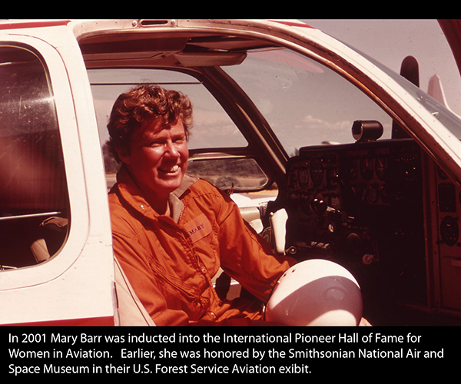
ROUND HOLE
(a short story - episode 2)
by Molly Barr

"It was a team of horses. Six of ‘em. They were pullin’, a load of freight. Pretty buckskins as I recall. I can still hear their screams sometimes when the sun sets."

"That was the day I met your Grandad," Grandma said. Her broad shoulders pushed through the screen-door and she placed a platter of cookies on a polished redwood stump near-by.

"Yep, it sure was.” Grandad stuffed a peanut butter cookie in his mouth, took a swig of the lemonade, and swiped the back of his hand across his lips. "It was pretty much a day like any other: hot ‘n dusty. The sage was in bloom and the hills were yellow. The Smoke Creek Desert out there," with a sweep of his hand, he pointed towards the immense alkali flat in the distance, "was as naked as always, and had a mirage pooled in the middle of it. Looked like a lake. I'd been out beatin’, the brush for strays since before dawn, when ole Jake - he was my horse—scared up a rattle snake.”

"Dumped Bruce on his butt, sure as hell," Grandma said. She tousled the old man's stone-gray hair, threw back her head and laughed.

"Yep, wouldn't a happened if I'd been tendin' to my business 'stead of wool gatherin’."

"It happens," Grandma said.

"Yep, it happens,” he agreed.

"That was back when I had a freight run from Reno on up to Gerlach, Nevada," Grandma said. "I was ornery in those days - bigger than most of the men, and twice as mean."

"You're ornery now," Grandad said. To me he added, "prettiest woman in these parts, that's for damn sure."

"That wasn't hard. In 1902, I was the ONLY woman in these parts." She grabbed a heavy hardwood chair under the window, swung it between Grandad and I, settled in, and crossed one denim-covered leg over the other.

"Any way," she continued, "I was a day or so out of Gerlach with a full load of freight for the miners up that way, when I spied this sorry heap of humanity in a gully ‘long side the trail. The dust was thick as tulle fog and I wasn't sure I'd seen anything till it moved."

(TO BE CONTINUED)

Notes from the Editor
Again, thanks to Barbara Fredericks for formatting and sending out this newsletter. Rachel Brown posts it on our Facebook page. Incidentally, if you are on Facebook, go to the Carquinez Village website and like us! Writers Joe Athey and Molly Barr continue to contribute regularly. Molly’s second episode of a continuing story is in the September issue. If you miss a segment, you can go to Carquinez Village website under “In the News” and read back issues there.
Do you have something to say next month? You can send it directly to my email, lois@requist.com. In the subject line, please say “newsletter.”

Our website contains a list of preferred providers, local businesses that Carquinez Village members have used and recommend. Whether you need a gardener, an accountant, or something else, check this list for reliable help.

Read the weekly updates that you receive each Sunday for all our ongoing events and look at the website for our more complete story. A reminder—if you’d like to go to an event on Zoom but are unsure of the technology, just let us know. Someone will help you. Call 707-297-2472 with any questions or comments.

 | 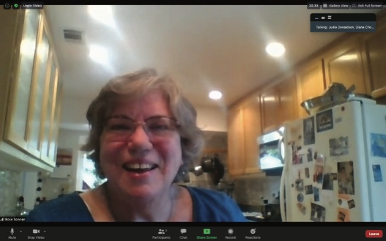 | Mayor Elizabeth Patterson speaking with Carquinez Village members in August as Rose Sonnen, a member, listens on.

Want More Involvement?

The membership committee, under the direction of Janice Magner, has wondered about ways to involve members in activities and facilitate friendships.

Isolation is our big enemy, both because of COVID-19, and because we tend to isolate more as we age. Finding our groups can be a great way to help us stay involved, safe, and engaged in meaningful activity.
Of course, because of the COVID restrictions, we must be creative. Already there is an active Vallejo group, a movie review group, and several other groups. Some of us have claimed other members as a part of our personal “pods”- those we interact with but remain masked or six feet apart from. It has been a great joy to meet these friends for meaningful activity, and we treasure it.

Being part of a group naturally lends itself to caring interactions among members. Rather than “cold calls” about “how are you, are you safe”, we are recommending members become engaged with others in Carquinez Village. Your friendship group is likely to know if you need something and can then help you get it.

After all, the Village is only effective when we engage with it.

